Theoretical

Exam

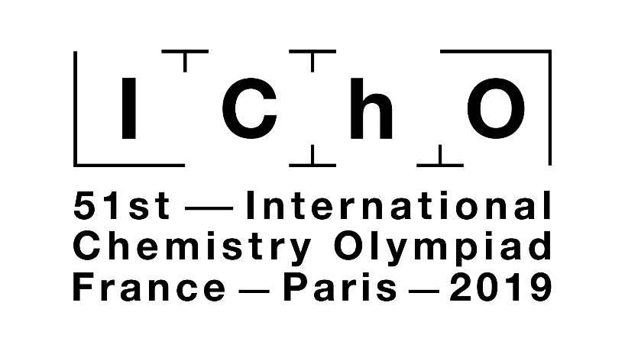

Making science together!

2019-07-26



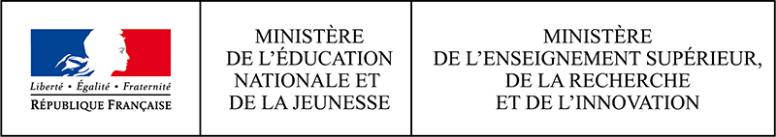

General instructions

* This theoretical exam booklet contains 61 pages.
* You may begin writing as soon as the Start command is given.
* You have 5 hours to complete the exam.
* All results and answers must be clearly written in pen in their respective designed areas on the exam papers. Answers written outside the answer boxes will not be graded.
* If you need scratch paper, use the backside of the exam sheets. Remember that nothing outside the designed areas will be graded.
* Use only the pen and calculator provided.
* The official English version of the exam booklet is available upon request and serves for clarification only.
* If you need to leave the exam room (to use the toilet or have a snack), wave the corresponding IChO card. An exam supervisor will come to accompany you.
* For multiple-choice questions: if you want to change your answer, fill the answer box completely and then make a new empty answer box next to it.
* The supervisor will announce a 30-minute warning before the Stop command.
* You must stop your work immediately when the Stop command is announced. Failure to stop writing by ½ minute or longer will lead to nullification of your theoretical exam.
* After the Stop command has been given, place your exam booklet back in your exam envelope, then wait at your seat. The exam supervisor will come to seal the envelope in front of you and collect it.

**GOOD LUCK!**

Table of Contents

This theoretical exam is composed of 9 independent problems, as follows. Their relative weight is indicated in parenthesis.

|  |  |  |
| --- | --- | --- |
| Problem T1: Infinite well and butadiene | (6%) | p. 8 |
| Problem T2: Hydrogen production by water-splitting | (7%) | p. 13 |
| Problem T3: About silver chloride | (5%) | p. 19 |
| Problem T4: From black powder to the discovery of iodine | (7%) | p. 24 |
| Problem T5: Complexes for the formation of nanomachines | (8%) | p. 30 |
| Problem T6: Characterization of a block-copolymer | (8%) | p. 39 |
| Problem T7: Ring motion in a [2]catenane | (6%) | p. 47 |
| Problem T8: Identification and synthesis of inositols | (6%) | p. 52 |
| Problem T9: Synthesis of levobupivacaine | (7%) | p. 57 |

Physical constants and equations

In these tasks, we assume the activities of all aqueous species to be well approximated by their respective concentration in mol L−1. To further simplify formulas and expressions, the standard concentration *c*° = 1 mol L−1 is omitted.

|  |  |
| --- | --- |
| Avogadro's constant: | *N*A = 6.022∙1023 mol−1 |
| Universal gas constant: | *R =* 8.314 J mol−1 K−1 |
| Standard pressure: | *p°* = 1 bar = 105 Pa |
| Atmospheric pressure: | *P*atm = 1 atm = 1.013 bar = 1.013∙105 Pa |
| Zero of the Celsius scale: | 273.15 K |
| Faraday constant: | *F* = 9.6485∙104 C mol−1 |
| Watt: | 1 W = 1 J s−1 |
| Kilowatt hour: | 1 kWh = 3.6∙106 J |
| Planck constant: | *h* = 6.6261∙10−34 J s |
| Speed of light in vacuum: | *c* = 2.998∙108 m s−1 |
| Elementary charge: | *e* = 1.6022∙10−19 C |
| Electron-volt | 1 eV = 1.6022∙10−19 J |
| Electrical power: | *P* = Δ*E*× *I* |
| Power efficiency: | *η* = *P*obtained/*P*applied |
| Planck-Einstein relation: | *E* = *hc*/*λ* = *hν* |
| Ideal gas equation: | *pV* = *nRT* |
| Gibbs free energy: | *G = H − TS* |
|  | Δr*G*° = *−RT*ln*K°*  Δr*G*° = *−n F E*cell*°* |
|  | Δr*G =*Δr*G*° + *RT*ln*Q* |
| Reaction quotient $\text{Q}$ for a reaction  *a* A(aq)+ *b* B(aq) *=* *c* C(aq)+ *d* D(aq): | $$Q=\frac{{\left[\text{C}\right]}^{\text{c}}{\left[\text{D}\right]}^{\text{d}}}{{\left[\text{A}\right]}^{\text{a}}{\left[\text{B}\right]}^{\text{b}}}$$ |
| Henderson*−*Hasselbalch equation: | $$\text{pH = p}{\text{K}}_{\text{a}}\text{ + log}\frac{\text{[}A^{-}]}{\text{[}AH]}$$ |
| Nernst–Peterson equation: | $\text{E}\text{ = }{\text{E}}^{\text{o}}-\frac{\text{RT}}{\text{z}\text{F}}\text{ln}Q$ |
| where *Q* is the reaction quotient of the reduction half-reaction | at *T* = 298 K, $\frac{\text{RT}}{\text{F}}\text{ln10 ≈ 0.0}\text{59 V}$ |
| Beer–Lambert law: | *A* = *εlc* |
| Rate laws in integrated form: |  |
| - Zero order: | [A] = [A]0 *− kt* |
| - First order: | ln[A] = ln[A]0 *− kt* |
| - Second order: | 1/[A] = 1/[A]0 + *kt* |
| Half-life for a first order process: | $$\frac{ln2}{k}$$ |
| Number average molar mass *M*n: |  |
| Mass average molar mass *M*w: |  |
| Polydispersity index *I*p: |  |

Periodic table

|  |  |  |  |  |  |  |  |  |  |  |  |  |  |  |  |  |  |
| --- | --- | --- | --- | --- | --- | --- | --- | --- | --- | --- | --- | --- | --- | --- | --- | --- | --- |
| 1 |  |  |  |  |  |  |  |  |  |  |  |  |  |  |  |  | 18 |
| 1 H 1.008 | 2 |  | | | | | | | | | | 13 | 14 | 15 | 16 | 17 | 2 He 4.003 |
| 3 Li 6.94 | 4 Be 9.01 | 5 B 10.81 | 6 C 12.01 | 7 N 14.01 | 8 O 16.00 | 9 F 19.00 | 10 Ne 20.18 |
| 11 Na 22.99 | 12 Mg 24.31 | 3 | 4 | 5 | 6 | 7 | 8 | 9 | 10 | 11 | 12 | 13 Al 26.98 | 14 Si 28.09 | 15 P 30.97 | 16 S 32.06 | 17 Cl 35.45 | 18 Ar 39.95 |
| 19 K 39.10 | 20 Ca 40.08 | 21 Sc 44.96 | 22 Ti 47.87 | 23 V 50.94 | 24 Cr 52.00 | 25 Mn 54.94 | 26 Fe 55.85 | 27 Co 58.93 | 28 Ni 58.69 | 29 Cu 63.55 | 30 Zn 65.38 | 31 Ga 69.72 | 32 Ge 72.63 | 33 As 74.92 | 34 Se 78.97 | 35 Br 79.90 | 36 Kr 83.80 |
| 37 Rb 85.47 | 38 Sr 87.62 | 39 Y 88.91 | 40 Zr 91.22 | 41 Nb 92.91 | 42 Mo 95.95 | 43 Tc - | 44 Ru 101.1 | 45 Rh 102.9 | 46 Pd 106.4 | 47 Ag 107.9 | 48 Cd 112.4 | 49 In 114.8 | 50 Sn 118.7 | 51 Sb 121.8 | 52 Te 127.6 | 53 I 126.9 | 54 Xe 131.3 |
| 55 Cs 132.9 | 56 Ba 137.3 | 57-71 | 72 Hf 178.5 | 73 Ta 180.9 | 74 W 183.8 | 75 Re 186.2 | 76 Os 190.2 | 77 Ir 192.2 | 78 Pt 195.1 | 79 Au 197.0 | 80 Hg 200.6 | 81 Tl 204.4 | 82 Pb 207.2 | 83 Bi 209.0 | 84 Po - | 85 At - | 86 Rn - |
| 87 Fr - | 88 Ra - | 89-103 | 104 Rf - | 105 Db - | 106 Sg - | 107 Bh - | 108 Hs - | 109 Mt - | 110 Ds - | 111 Rg - | 112 Cn - | 113 Nh - | 114 Fl - | 115 Mc - | 116 Lv - | 117 Ts - | 118 Og - |
|  |  |  |  |  |  |  |  |  |  |  |  |  |  |  |  |  |  |
|  |  |  | 57 La 138.9 | 58 Ce 140.1 | 59 Pr 140.9 | 60 Nd 144.2 | 61 Pm - | 62 Sm 150.4 | 63 Eu 152.0 | 64 Gd 157.3 | 65 Tb 158.9 | 66 Dy 162.5 | 67 Ho 164.9 | 68 Er 167.3 | 69 Tm 168.9 | 70 Yb 173.0 | 71 Lu 175.0 |
|  |  |  | 89 Ac - | 90 Th 232.0 | 91 Pa 231.0 | 92 U 238.0 | 93 Np - | 94 Pu - | 95 Am - | 96 Cm - | 97 Bk - | 98 Cf - | 99 Es - | 100 Fm - | 101 Md - | 102 No - | 103 Lr - |





1H NMR

Chemical shifts of hydrogen (in ppm / TMS)

|  |  |  |  |  |  |  |  |  |  |  |  |  |  |  |  |  |  |  |  |  |  |  |  |
| --- | --- | --- | --- | --- | --- | --- | --- | --- | --- | --- | --- | --- | --- | --- | --- | --- | --- | --- | --- | --- | --- | --- | --- |
| phenols: | | |  |  |  |  |  |  |  |  |  |  |  |  |  |  |  |  |  |  |  |  |  |
|  |  |  |  |  |  |  |  |  |  |  |  |  |  |  |  |  |  |  |  |  |  |  |  |
|  |  |  |  |  |  |  | alcohols: | | |  |  |  |  |  |  |  |  |  |  |  |  |  |  |
|  |  |  |  |  |  |  |  |  |  |  |  |  |  |  |  |  |  |  |  |  |  |  |  |
|  |  |  |  | alkenes: | | |  |  |  |  |  |  |  | alkynes: | | |  | CH3—CR3: | | |  |  |  |
|  |  |  |  |  |  |  |  |  |  |  |  |  |  |  |  |  |  |  |  |  |  |  |  |
|  |  |  |  |  |  |  |  |  |  | amines: | | |  |  |  |  |  |  |  |  |  |  |  |
|  |  |  |  |  |  |  |  |  |  |  |  |  |  |  |  |  |  |  |  |  |  |  |  |
|  | amide NH—COR: | | | | |  |  |  |  |  |  |  |  |  |  |  | :R—CH2—OR’ | | | | |  |  |
|  |  |  |  |  |  |  |  |  |  |  |  |  |  |  |  |  |  |  |  |  |  |  |  |
|  |  |  |  |  | :carboxylic acids | | | | |  |  |  | CH3—NR2: | | |  |  |  |  | CH3—SiR3: | | |  |
|  |  |  |  |  |  |  |  |  |  |  |  |  |  |  |  |  |  |  |  |  |  |  |  |
|  |  |  |  | :aldehydes | | |  |  |  |  |  |  |  |  |  |  |  |  | :ketones | | |  |  |
|  |  |  |  |  |  |  |  |  |  |  |  |  |  |  |  |  |  |  |  |  |  |  |  |
|  |  |  |  | aromatics: | | |  |  |  |  | benzylic CHn—C6H5: | | | | | |  |  |  |  |  |  |  |
|  |  |  |  |  |  |  |  |  |  |  |  |  |  |  |  |  |  |  |  |  |  |  |  |
| 11.0 | | 10.0 | | 9.0 | | 8.0 | | 7.0 | | 6.0 | | 5.0 | | 4.0 | | 3.0 | | 2.0 | | 1.0 | | 0.0 | |

H-H coupling constants (in Hz)

|  |  |
| --- | --- |
| **Hydrogen type** | **|*J*ab| (Hz)** |
| R2CHaHb | 4-20 |
| R2HaC—CR2Hb | 2-12  if free rotation: 6-8  ax-ax (cyclohexane): 8-12  ax-eq or eq-eq (cyclohexane): 2-5 |
| R2HaC—CR2—CR2Hb | if free rotation: < 0.1  otherwise (rigid): 1-8 |
| RHaC=CRHb | *cis*: 7-12  *trans*: 12-18 |
| R2C=CHaHb | 0.5-3 |
| Ha(CO)—CR2Hb | 1-3 |
| RHaC=CR—CR2Hb | 0.5-2.5 |

eq = equatorial, ax = axial

IR spectroscopy table

|  |  |  |
| --- | --- | --- |
| **Vibrational mode** | ***σ* (cm−1)** | **Intensity** |
| alcohol O—H (stretching)  carboxylic acid O—H (stretching)  N—H (stretching)  ≡C—H (stretching)  =C—H (stretching)  C—H (stretching)  –(CO)—H (stretching)  C≡N (stretching)  C≡C (stretching)  aldehyde C=O (stretching)  anhydride C=O (stretching)  ester C=O (stretching)  ketone C=O (stretching)  amide C=O (stretching)  alkene C=C (stretching)  aromatic C=C (stretching)  CH2 (bending)  CH3 (bending)  C—O—C (stretching)  C—OH (stretching)  NO2 (stretching) | 3600-3200  3600-2500  3500-3350  3300  3100-3000  2950-2840  2900-2800  2250  2260-2100  1740-1720  1840-1800; 1780-1740  1750-1720  1745-1715  1700-1500  1680-1600  1600-1400  1480-1440  1465-1440; 1390-1365  1250-1050  1200-1020  1600-1500; 1400-1300 | strong  strong  strong  strong  weak  weak  weak  strong  variable  strong  weak; strong  strong  strong  strong  weak  weak  medium  medium  strong  strong  strong |

|  |  |  |  |  |  |  |  |  |  |  |  |  |  |
| --- | --- | --- | --- | --- | --- | --- | --- | --- | --- | --- | --- | --- | --- |
| **Problem**  **T1**  **6%** | **Question** | **1** | **2** | **3** | **4** | **5** | **6** | **7** | **8** | **9** | **10** | **11** | **Total** |
| Points | 3 | 4 | 4 | 2 | 3 | 2 | 2 | 4.5 | 2.5 | 3 | 3 | 33 |
| Score |  |  |  |  |  |  |  |  |  |  |  |  |

Problem T1: Infinite well and butadiene

The buta-1,3-diene molecule is often written CH2=CH–CH=CH2, with alternating single and double bonds. Nevertheless, its chemical reactivity is not consistent with this description and the π electrons are better described by a distribution along the three bonds:



This system can be modeled as a 1D box (*i.e.* infinite well) where the electrons are free. The energy of an electron in an infinite well of length *L* is: $E_{n}= \frac{n^{2}h^{2}}{8m_{e}L^{2}}$, where *n* is a **non-zero** positive integer.

1. Two different models are studied. **Sketch** at least the three lowest-energy levels *E*n **for each model** in the respective diagrams, showing how the relative energy levels differ within and between models.

|  |  |
| --- | --- |
|  | |
| **Model 1 (« localized »)**: The π electrons are localized on the extremal bonds and evolve in two separate infinite potential wells of length *d*. | **Model 2 (« delocalized »)**: The π electrons are delocalized on the whole molecule and evolve in a single infinite potential well of length 3*d*. |

1. **Place** the π electrons for model 1 in the previous diagrams and **express** the total energy of the π system in model 1, as a function of *h*, *m*e and *d*.

*E*(1) =

1. **Place** the π electrons for model 2 in the previous diagrams and **express** the total energy of the π system in model 2, as a function of *h*, *m*e and *d*.

$$E\left(2\right)=$$

The conjugation energy is the total energy of the actual π system, minus the sum of the energies of ethylene molecules involving the same number of electrons.

1. **Express** the conjugation energy Δ*E*c of butadiene, as a function of *h*, *m*e and *d*.

$${∆E}_{c}=$$

Models 1 and 2 are too simplistic. A new model will be detailed in the following.

1. **Draw** three other resonance structures of butadiene using Lewis notation.

|  |  |  |  |
| --- | --- | --- | --- |
|  |  |  |  |

To take into account the size of carbon atoms, model 2 is now modified into model 3, as follows:

- the new length of the well is *L* and is located between the abscissa 0 and *L*;

- the carbon atoms are located at the abscissas *L*/8; 3*L*/8; 5*L*/8 and 7*L*/8.

For each level *n*, the π wavefunction is:

$$ψ_{n}\left(x\right)= \sqrt{\frac{2}{L}}\sin\left(\frac{nπx}{L}\right)$$

and the π electron density for a system with *N* π electrons is:

$$ρ\left(x\right)= 2 \sum_{i=1}^{N/2}{{\left|ψ_{i}(x)\right|}^{2}}$$

The four π wavefunctions, which correspond to the molecular orbitals of the π system, are depicted below (**arbitrary order)**.

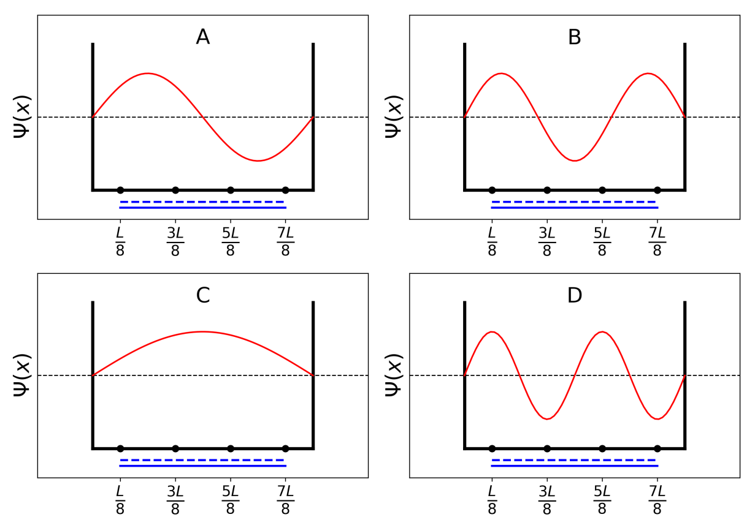

1. **Sort** the energies of the four π wavefunctions (*E*A, *E*B, *E*C and *E*D).

<  < <

1. **Give** the labels (A, B, C or D) of the orbitals that are filled with electrons in butadiene.
2. Within model 3, **give** the values of the π wavefunctions $ψ_{n}$ for occupied levels at positions 0, *L*/4 and *L*/2, for *n* = 1 and *n*= 2, as a function of *L*.
$$ψ_{1}\left(0\right)=$$

$$ψ_{1}\left(\frac{L}{4}\right)=$$

$$ψ_{1}\left(\frac{L}{2}\right)=$$

$$ψ_{2} (0)=$$

$$ψ_{2}\left(\frac{L}{4}\right)=$$

$$ψ_{2} \left(\frac{L}{2}\right)=$$

3. Within model 3, **give** the value of the π electron density at positions 0, *L*/4 and *L*/2.
$$ρ\left(0\right)=$$

$$ρ\left(\frac{L}{4}\right)=$$

$$ρ\left(\frac{L}{2}\right)=$$

4. **Draw** the π electron density between 0 and *L*.

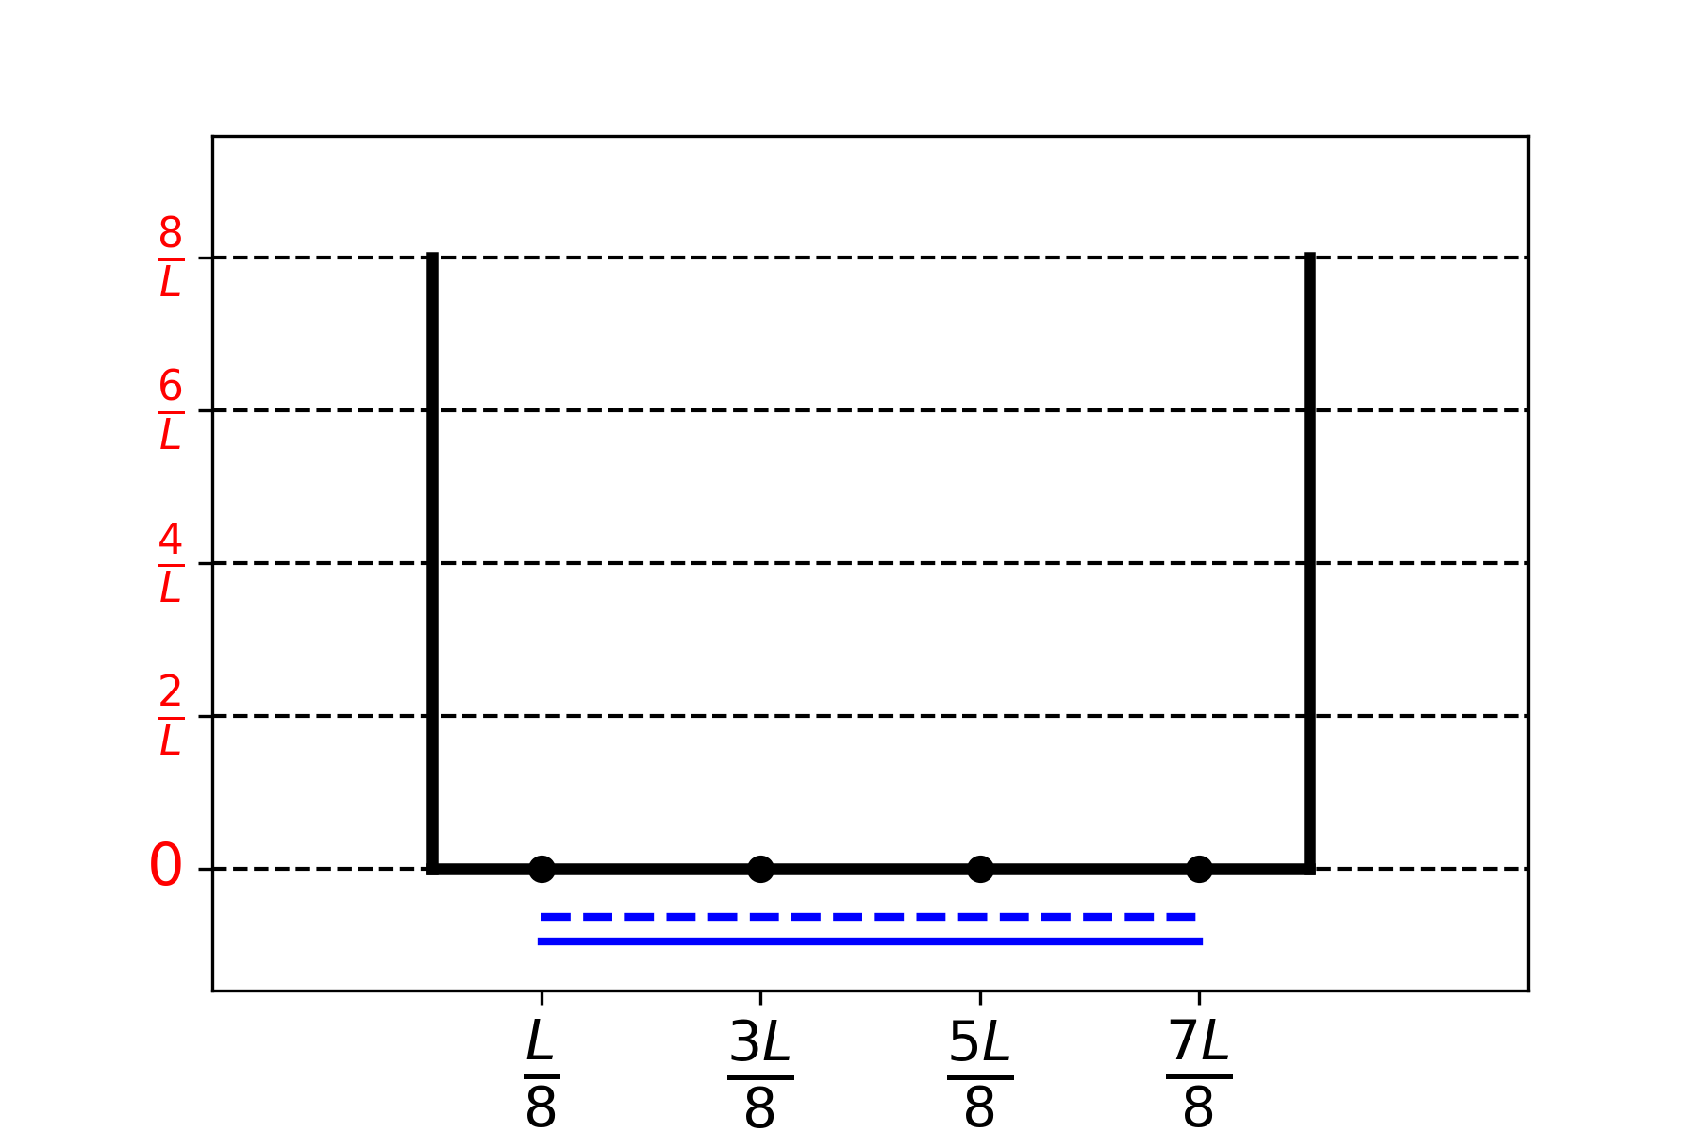

1. **Sort** the following CC bonds (B1, B2, …, B5) by increasing length, using the symbols = or <:

B1: C1C2 in the butadiene molecule

B2 : C2C3 in the butadiene molecule

B3 : C3C4 in the butadiene molecule

B4 : CC in the ethane molecule

B5 : CC in the ethene molecule

|  |  |  |  |  |  |  |  |  |  |  |  |  |
| --- | --- | --- | --- | --- | --- | --- | --- | --- | --- | --- | --- | --- |
| **Problem**  **T2**  **7%** | **Question** | **1** | **2** | **3** | **4** | **5** | **6** | **7** | **8** | **9** | **10** | **Total** |
| Points | 1 | 4 | 2 | 3 | 3 | 6 | 4 | 1 | 8 | 2 | 34 |
| Score |  |  |  |  |  |  |  |  |  |  |  |

Problem T2: Hydrogen production by water-splitting

Data:

|  |  |  |  |  |
| --- | --- | --- | --- | --- |
| Compound | H2(g) | H2O(l) | H2O(g) | O2(g) |
| ∆f*H*° (kJ mol−1) | 0 | −285.8 | −241.8 | 0 |
| *S*m° (J mol−1K−1) | 130.6 | 69.9 | 188.7 | 205.2 |

Molecular hydrogen (H2) can be used as an alternative to carbon dioxide-emitting fuels. Hence, lowering the cost and the environmental impact of its production is a major challenge. In this field, water-splitting is a promising candidate technology.

1. **Write down** the balanced equation of liquid water splitting reaction using a stoichiometric coefficient of 1 for water.
2. Using only the provided thermodynamic data, **justify numerically** whether this reaction is thermodynamically favorable at 298 K.

Calculations:

Reaction thermodynamically favorable?

🞎 Yes 🞎 No

Water splitting can be performed electrochemically using two electrodes in an acidic water bath, connected by a generator (Fig. 1). Gas bubbles are formed at both electrodes.



Fig. 1 – Water-splitting electrochemical cell.

1. **Write down** the balanced net electrochemical half reactions occurring at each electrode.

On electrode (1):

On electrode (2):

1. Using only the provided thermodynamic data (or question 2), **derive** the condition on the applied voltage Δ*E*applied between electrodes, compared to value Δ*E*th (to **determine**), for the process to be thermodynamically favorable at 298 K, when all reactants and products are in their standard state. **Tick** the right condition and **give** the numerical value with 3 decimal places.

Calculation:

* Δ*E*applied = Δ*E*th

🞎 Δ*E*applied > Δ*E*th , where Δ*E*th ……….. V

* Δ*E*applied < Δ*E*th (give the result with 3 decimal places)

*If you could not calculate* Δ*E*th*, the value 1.200 V  
can be used in the rest of the problem.*

Experimentally, a higher voltage is needed to observe water splitting. For a given Pt cathode, the minimum voltage necessary to observe water splitting, Δ*E*min, depends on the nature of the anode, as displayed in the table below:

|  |  |
| --- | --- |
| Anode | Δ*E*min (V) |
| IrO*x* | 1.6 |
| NiO*x* | 1.7 |
| CoO*x* | 1.7 |
| Fe2O3 | 1.9 |

The difference between Δ*E*min and Δ*E*th is responsible for losses in the device.

1. **Give** the expression of the device power efficiency *η*elec (fraction of the power used for water splitting) as a function of Δ*E*th and Δ*E*min. Assuming an identical current value *I*, **calculate** the water electrolysis power efficiency when a Pt cathode and a Fe2O3 anode are used. **Give** the most efficient anode.

*η*elec =

Power efficiency when a Pt and a Fe2O3 electrodes are used:

*η*elec =  %

Most efficient anode:

*If you could not calculate* *η*elec*, the value η*elec = *75%  
can be used in the rest of the problem.*

An alternative to water electrolysis is direct photocatalytic water-splitting. It uses a semiconductor that can be activated by absorbing light.

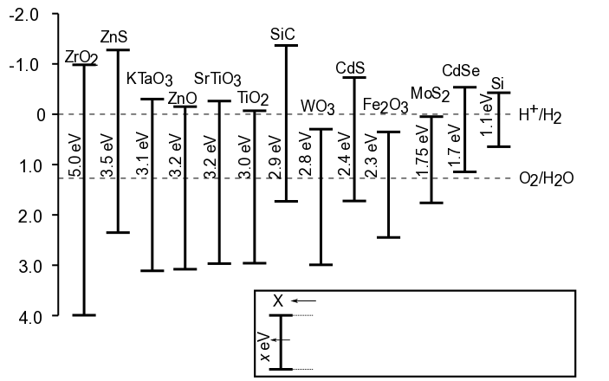

Name of semiconductor

Potential of equivalent cathode

** : Minimal light energy to activate

Potential of equivalent anode

V vs SHE

Fig. 2 – Activation condition and equivalent electrode potentials of different semiconductors. Dashed lines correspond to water oxidation and reduction potentials. SHE = Standard Hydrogen Electrode

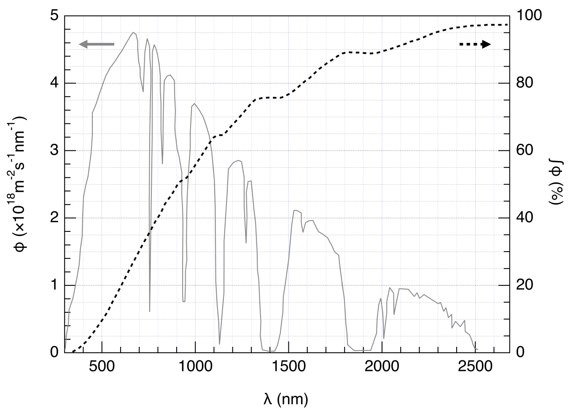

Fig. 3 – Left axis: Spectral distribution of the solar photon flux φ. The photon flux is the number of photons per unit area per unit time arriving on the semiconductor. Right axis and dashed line: cumulative photon flux (i.e. fraction of the photon flux with smaller wavelength).

1. **Estimate** the fraction of the solar photon flux that can activate the following semiconductors: TiO2, CdS, Si. **State** explicitly the equations and units used for the computation.

Explanation / calculation:

|  |  |
| --- | --- |
|  | Approximate fraction |
| TiO2 | % |
| CdS | % |
| Si | % |

The activation of the semi-conductor results in a modification of the surface potentials, so that it can be seen as two electrodes of different potentials.

1. Using the data in Fig 2, **choose** the semiconductor(s) in the following list that, once activated, can play both roles of anode and cathode for water-splitting reaction.

🞎ZrO2 🞎 ZnO 🞎 TiO2 🞎 WO3

🞎CdS 🞎 Fe2O3 🞎 CdSe🞎 Si

1. **Give** the semiconductor that, used as both cathode and anode, is expected to be the most efficient for water splitting upon a given solar shining.

The evolution of H2 and O2 when a semiconductor is irradiated by simulated solar light at *T* = 25 °C at *p*atm was recently studied. Using an incident power light of *P* = 1.0 kW m−2 and a photoelectrode with a *S* = 16 mm2 surface, the production of *V* = 0.37 cm3 of H2(g) was measured after Δ*t* = 1 hour of reaction.

1. **Calculate** the power efficiency *η*direct of the conversion.

Calculation:

*η*direct = %

*If you could not calculate* *η*direct*, the value η*direct = *10%  
can be used in the rest of the problem.*

Two modes of converting solar energy to hydrogen can thus be compared: direct photocatalysis, and indirect photo-electrolysis combining a photovoltaic panel with an electrolyzer. The efficiency of photovoltaic panels on the market is around *η*panels = 20%.

1. **Compare** the power efficiencies of the two modes, *η*direct and *η*indirect, using Fe2O3 and Pt electrodes for the electrolysis.

Calculation:

🞎*η*direct > *η*indirect 🞎*η*direct ≈ *η*indirect 🞎*η*direct < *η*indirect

|  |  |  |  |  |  |  |  |  |  |  |  |  |  |  |
| --- | --- | --- | --- | --- | --- | --- | --- | --- | --- | --- | --- | --- | --- | --- |
| **Problem**  **T3**  **5%** | **Question** | **1** | **2** | **3** | **4** | **5** | **6** | **7** | **8** | **9** | **10** | **11** | **12** | **Total** |
| Points | 1 | 3 | 3 | 3 | 4 | 2 | 7 | 2 | 2 | 3 | 4 | 6 | 40 |
| Score |  |  |  |  |  |  |  |  |  |  |  |  |  |

Problem T3: About silver chloride

Data at 298 K:

p*K*s1(AgCl) = 9.7; p*K*s2(Ag2CrO4) = 12

Formation constant of the complex [Ag(NH3)n]+: *β*n = 107.2

Potentials against the standard hydrogen electrode:

Standard potential of Ag+/Ag(s): *E*°(Ag+/Ag(s)) = 0.80 V

Apparent potential of O2(aq)/HO−(aq) (in seawater): *E'*(O2(aq)/HO−(aq)) = 0.75 V

Part A: Quotes from a chemistry lesson by Louis Joseph Gay-Lussac

The following quotes from a chemistry lesson by Louis Joseph Gay-Lussac (French chemist and physicist, 1778–1850) deal with some properties of silver chloride.

**Quote A:** “I will now talk about silver chloride, a milk-white solid. It is easily obtained by pouring hydrochloric acid into an aqueous solution of silver nitrate.”

**Quote B:** “This salt has no taste since it is insoluble.”

**Quote C:** “This compound is completely insoluble in alcohol and even in acids, except in concentrated hydrochloric acid which dissolves it readily.”

**Quote D:** “On the other hand, silver chloride is highly soluble in aqueous solution of ammonia.”

**Quote E:** “Then, we can make silver chloride appear again by adding an acid which reacts with ammonia.”

**Quote F:** “If you take a bowl made of silver to evaporate salty seawater, you will get impure sodium chloride, mixed with a milk-white solid.”

1. **Quote A:** **Write** the balanced chemical equation of AgCl(s) synthesis.

1. **Quote B:** **Calculate** the solubility *s* of AgCl(s) in water at 298 K in mol L−1.

Calculation:

*s* = mol L−1

1. **Quote C:** In a highly concentrated solution of chloride ions, a well-defined complex of stoichiometry 1:2 is formed. On the following qualitative axis (with pCl increasing from left to right), **place** in each domain the silver-containing species that is predominant (or exists, for solids). pCl values at frontiers are not expected.

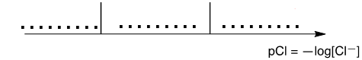

**Quote D:** When ammonia is added to silver chloride, a well-defined complex of stoichiometry *n* is formed.

1. **Write** the balanced equation corresponding to the synthesis of the complex [Ag(NH3)n]+ from silver chloride and **calculate** the corresponding equilibrium constant.

Equation:

Calculation:

*K* =

*If you could not calculate K, the following value   
can be used in the rest of the problem: K = 10‒3*

1. Ammonia is added to 0.1 mol of silver chloride in 1 L of water until the last grain of solid disappears. At this moment, [NH3] = 1.78 mol L−1. **Determine** the stoichiometry of the complex neglecting dilution effects.

Calculation:

*n* =

1. **Write** the balanced chemical equation corresponding to **quote E**.
2. Assuming that seawater is slightly basic and rich in dioxygen, and that silver metal can reduce dioxygen in such conditions, **write** a balanced chemical equation corresponding to the formation of the solid mentioned in **quote F.** A stoichiometric coefficient of 1 will be chosen for dioxygen. **Calculate** its equilibrium constant at 298 K.

Equation:

Calculation:

*K* =

Part B: The Mohr method

The Mohr method is based on the colorimetric titration of Cl− by Ag+ in the presence of potassium chromate (2K+, CrO42−). Three drops (~ 0.5 mL) of a K2CrO4 solution at about 7.76∙10−3 mol L−1 are added to V0 = 20.00 mL of a sodium chloride solution of unknown concentration *C*Cl. This solution is then titrated by silver nitrate (Ag+, NO3−) at *C*Ag = 0.050 mol L−1, which immediately leads to the formation of solid **A**. A red precipitate (solid **B**) appears at *V*Ag = 4.30 mL.

1. **Write** the balanced equations of the two reactions occurring during the experiment. **Calculate** the corresponding equilibrium constants.

*K*°1 =

*K*°2 =

1. **Identify** the solids.

Solid **A**:

Solid **B**:

1. **Calculate** the unknown concentration *C*Cl of chloride ions in the sodium chloride solution.

Calculation:

*C*Cl = mol L–1

*If you could not calculate* *C*Cl*, the value C*Cl *= 0.010 mol L−1  
can be used in the rest of the problem.*

1. **Calculate** the minimal volume *V*Ag(min) for which AgCl(s) precipitates.

Calculation:

*V*Ag(min) = mL

1. **Calculate** the residual concentration [Cl−]res of chloride ions when silver chromate begins to precipitate. **Justify** why CrO42− is a good titration endpoint indicator by comparing two values.

Calculation:

[Cl‒]res = mol L‒1

CrO42− is a good titration endpoint indicator because:

|  |  |  |  |  |  |  |  |  |  |  |
| --- | --- | --- | --- | --- | --- | --- | --- | --- | --- | --- |
| **Problem**  **T4**  **7%** | **Question** | **1** | **2** | **3** | **4** | **5** | **6** | **7** | **8** | **Total** |
| Points | 6 | 9 | 8 | 5 | 6 | 2 | 2 | 12 | 50 |
| Score |  |  |  |  |  |  |  |  |  |

Problem T4: From gunpowder to the discovery of iodine

In the 19th century, the French entrepreneur B. Courtois specialized in the production of nitrate **A** (**MA**(NO3)*m*), used for gunpowder. Initially imported from Asia, **A** was later produced from nitrate **B** (**MB**(NO3)*n*) using exchange reaction with compound **C**, obtained from algae.

1. **Find** the formulas of nitrates **A** and **B** knowing that they are anhydrous salts of alkaline or alkaline-earth metal (**MA** and **MB**). One of the nitrates contains no more than 1 w% of non-metallic impurities while the other contains 9 ± 3 w% of impurities. The content of metals **MA** and **MB** in the samples is 38.4 w% and 22.4 w% respectively. **Support** your answer with calculations.

**A**:  and **B**:

To obtain **A**, 262.2 g of solid compound **C** were added to the solution containing 442.8 g of **B**. **B** is known to be in excess. As a result, 190.0 g of white precipitate **D** were formed and removed by filtration. The filtrate was evaporated, and the obtained solid mixture **E** was heated until the mass of the sample (containing only nitrites, NO2−) was constant. The only gaseous product was dioxygen: 60.48 L at 0 °C at 1 atm (dioxygen can be considered as an ideal gas).

1. **Calculate** the composition (in w%) of mixture **E** considering that it contained only compounds **A** and **B** and no other impurities, and that **C** was taken in pure anhydrous state.

w% of **A**:  and of **B**:

1. **Determine** the formulas of compounds **C** and **D** and **write** the balanced reaction equation between **B** and **C**.

**C**: and **D**:

Reaction between **B** and **C**:

In 1811, when working with algae ashes, Courtois observed that copper vessels were worn out faster than usual. While he was studying this phenomenon, his cat entered the laboratory and spilled the solution of concentrated sulfuric acid on the dry algae ashes: violet vapors instantly came out of the vessel (**1**, sulfuric acid is the oxidizing agent): iodine (I2) had just been discovered! Iodine was the cause of the copper corrosion **(2)**. However, because of the medicinal applications of iodine, Courtois opened a new manufacture to produce it by reaction of algae with chlorine (**3**).

Nowadays, iodine is prepared from the set of reactants (NO3*−*, I*−*, H+) (**4**) or (IO3*−*, I*−*, H+) (**5**).

1. **Write** balanced equations for reactions **1–5**.

|  |
| --- |
| **1** |
| **2** |
| **3** |
| **4** |
| **5** |

The solubility of iodine is very low in water but significantly increases when iodide ions are added. Together they form ions such as triiodide, I3*−*:

I−(aq) + I2(aq) = I3−(aq) (**6**)

Equilibrium (**6**) can be studied through the extraction of I2 with dichloromethane. Indeed, I− and I3− do not dissolve in organic solvents but I2 does and, when extracted, it is 15 times more concentrated in dichloromethane than in water.

The following experiment was performed. To prepare the initial solution, a few crystals of solid iodine were dissolved in 50.0 mL of an aqueous solution of potassium iodide (0.1112 g). Then, 50.0 mL of dichloromethane were added, and the mixture was vigorously shaken until equilibration. After phase separation, each phase was titrated by 16.20 mL (organic phase) and by 8.00 mL (aqueous phase) of the standard aqueous solution of sodium thiosulphate pentahydrate (14.9080 g in 1.000 L of solution) in the presence of starch. The process is schematically represented below:





1. **Find** the correspondence between the stages on the scheme (**1**–**9**) and the schematic pictures representing them (**a**–**i**).

|  |  |
| --- | --- |
| Stages | Picture |
| 1 |  |
| 2 |  |
| 3 |  |
| 4 |  |
| 5 |  |
| 6 |  |
| 7 |  |
| 8 |  |
| 9 |  |

1. **Write** balanced equations for the two possible chemical reactions in the aqueous phase during the titration involving iodine species and sodium thiosulphate.
2. **Calculate** the mass of iodine used to prepare the initial solution.

*m*(I2) = g

1. **Calculate** the equilibrium constant *K°* for equilibrium of reaction (**6**).

*K*° =

|  |  |  |  |  |  |  |  |  |  |  |  |  |  |  |
| --- | --- | --- | --- | --- | --- | --- | --- | --- | --- | --- | --- | --- | --- | --- |
| **Problem**  **T5**  **8%** | **Question** | **1** | **2** | **3** | **4** | **5** | **6** | **7** | **8** | **9** | **10** | **11** | **12** | **Total** |
| Points | 3 | 4 | 4 | 2 | 5 | 5 | 4 | 3 | 5 | 2 | 2 | 2 | 41 |
| Score |  |  |  |  |  |  |  |  |  |  |  |  |  |

Problem T5: Azobenzene – β-cyclodextrin complexes for the formation of nanomachines

Nanomachines are molecular assemblies that enable the transformation of an energy source into a nano-movement for applications such as drug delivery. Numerous nanomachines make use of the isomerization of azo compounds (R–N=N−R’) upon irradiation.

1. **Draw** the stereoisomers of azobenzene (H5C6–N=N–C6H5) and **draw** a line between the two carbon atoms that are the furthest apart. **Compare** these two distances (*d*trans and *d*cis).

|  |  |
| --- | --- |
|  |  |
| *trans* | *cis* |
| Comparison: *d*trans  *d*cis | |



Fig. 1 – Possible reactants for the synthesis of **M**.

1. **M** can be synthesized in two steps from simple reactants (Fig. 1). **Choose** among the suggested reactants (**N** to **Q**) the ones that can provide **M** with very high regioselectivity. Sodium nitrite (NaNO2) in cold aqueous hydrochloric acid is used as reagent for the first step of the synthesis.

Reactants:  and

Determination of the association constant *K*t

β-cyclodextrin (**C**, Fig. 2) is a cyclic heptamer of glucose, which can form inclusion complexes with azo compounds. In tasks 3 to 6, we will determine by spectroscopy the association constant *K*t, corresponding to the formation of the inclusion complex CMtrans as depicted in Fig. 2.



Fig. 2 – Formation of the **CMtrans** inclusion complex.

Several solutions are prepared by mixing **C** and **Mtrans** in different proportions to reach initial concentrations [**C**]0 and [**Mtrans**]0. While [**Mtrans**]0 is identical for all solutions, [**C**]0 varies. We follow, at a fixed wavelength, the evolution of the difference in absorbance Δ*A* between the absorbance of each solution and the pure **Mtrans** solution. We note the molar absorption coefficients of **CMtrans** and **Mtrans**, *ε*CMtransand *ε*Mtrans, respectively. *L* is the path length of the beam through the sample. The absorbance of **C** (*ε*C) is negligible.

1. **Demonstrate** that Δ*A= α ·*[**CMtrans**] and **express** *α* in terms of known constant(s).

Demonstration:

*α =*

1. **Demonstrate** that, when **C** is in large excess with respect to **Mtrans** (*i.e.* [**C**]0 >> [**Mtrans**]0), the concentration of **C** may be considered as constant, [**C**] ≃ [**C**]0.

Demonstration:

1. **Demonstrate** that, when **C** is in large excess with respect to **Mtrans** (*i.e.* [**C**]0 >> [**Mtrans**]0),  
    and **express** *β* in terms of constant(s) and initial concentration(s).

Demonstration:

*β* =

1. **Determine** *K*t using the following experimental curve (Fig. 3).

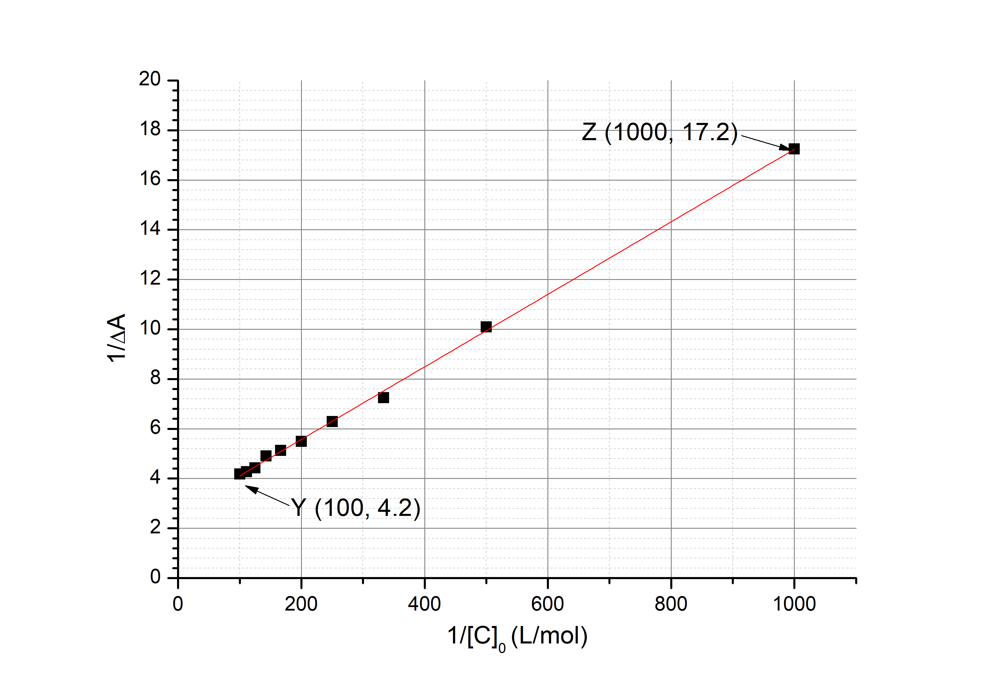

Fig. 3 – Evolution of 1/ $∆$ A as a function of 1/[**C**]0.

Calculations:

*K*t =

Determination of the association constant *K*c

In tasks 7 to 9, we will determine by kinetic studies the association constant *K*c, corresponding to the formation of the inclusion complex with **Mcis, CMcis**. A sample containing only **Mtrans** is irradiated, thus producing a known amount of **Mcis**, [**Mcis**]0. **Mcis** (free or within the inclusion complex) then thermally isomerizes into **Mtrans**. In the absence of **C**, the isomerization follows a first order kinetics with a rate constant *k*1. All complexation equilibria are faster than the isomerization processes. The kinetic scheme corresponding to this experiment is provided in Fig. 4.



Fig. 4 – Kinetic scheme for the isomerization of **Mcis** in the presence of **C**.

The rate of disappearance *r* for the total amount of **Mcis** (free and complexed) is defined as

*r* = *k*1[**Mcis**] + *k*2[**CMcis**]

Experimentally, *r* follows an apparent first order kinetic law with an apparent rate constant *k*obs:

*r* = *k*obs([**Mcis**] + [**CMcis**])

1. **Demonstrate** that $k_{obs}=\frac{γ+δ∙k_{2}[C]}{1+K_{c}[C]}$ and **express** *γ* and *δ* in terms of known constant(s).

Demonstration:

*γ* =  and *δ* =

1. **Choose** in which condition(s) the half-life *t*1/2 corresponding to *k*obs can be expressed as $t_{1/2}= \frac{ln2}{γ } (1+ K_{c}{[C]}_{0})$ 
    given that [**C**]0 >> [**Mcis**]0. Mathematically **justify** your answer.

🞎 Very slow isomerization of **Mcis** within cyclodextrin

🞎 Very slow isomerization of free **Mcis**

🞎 **CMcis** very stable

🞎 **CMtrans** very stable

Demonstration:

1. Assuming the condition(s) in task 8 satisfied, **determine** *K*c by a linear regression using the data below. You may use a calculator or plot a graph.

|  |  |  |  |
| --- | --- | --- | --- |
| [**C**]0 (mol L−1) | *t*1/2 (s) | [**C**]0 (mol L−1) | *t*1/2 (s) |
| 0 | 3.0 | 3.0·10−3 | 5.9 |
| 1.0·10−4 | 3.2 | 5.0·10−3 | 7.7 |
| 5.0·10−4 | 3.6 | 7.5·10−3 | 9.9 |
| 1.0·10−3 | 4.1 | 1.0·10−2 | 12.6 |



Equation of the linear regression:

*K*c =

Formation of nanomachines



Fig. 5 – Cleavage of an azobenzene ̶ cyclodextrin inclusion complex induced by a light-triggered isomerization, which allows delivery of a dye (grey circles).

Another azobenzene compound (for which *K*c<< *K*t), initially in the *trans* form, is covalently grafted on silica (Fig. 5). The silica pores are filled with a dye (rhodamine B, grey circles in Fig. 5). Upon addition of **C**, an inclusion complex is formed, which blocks the pores and prevents the release of the dye.

1. **Choose** the most appropriate condition (one choice only) so that the pores are initially blocked in the presence of **C**, and the dye can be released upon irradiation.

🞎 *K*t >> 1

🞎 *K*t >> 1 and *K*c << 1

🞎 *K*t / *K*c << 1

🞎 *K*t >> 1 and *K*c >> 1

🞎 *K*c << 1

This azobenzene-silica powder loaded with a dye is placed in the corner of a cuvette (Fig. 6) so that the powder cannot move into solution. The powder is irradiated at a wavelength *λ*1 to trigger the release of the dye from the pores (Fig. 5). To monitor this release by absorbance spectroscopy we measure the absorbance of the solution at wavelength *λ* 2.

|  |  |
| --- | --- |
|  |  |

Fig. 6 – Left: experimental setup used to monitor the release of the dye; right: absorption spectra of trans-azobenzene (full line), cis-azobenzene (dotted line) and rhodamine B (dashed line).

1. **Determine** *λ*1.

*λ*1 = nm

1. **Determine** *λ*2.

*λ*2 = nm

|  |  |  |  |  |  |  |  |  |  |  |  |
| --- | --- | --- | --- | --- | --- | --- | --- | --- | --- | --- | --- |
| **Problem**  **T6**  **8%** | **Question** | **1** | **2** | **3** | **4** | **5** | **6** | **7** | **8** | **9** | **Total** |
| Points | 4 | 4 | 5 | 3 | 10 | 2 | 9 | 6 | 5 | 48 |
| Score |  |  |  |  |  |  |  |  |  |  |

Problem T6: Characterization of a block-copolymer

Block-copolymers, obtained by linking different polymers (blocks), have unique properties, such as the ability to self-assemble. In this problem, the synthesis and characterization of such a macromolecule are studied.

Study of the first block



In this first part, we will study the water soluble homopolymer **1** (α-methoxy-ω-aminopolyethyleneglycol).

The 1H NMR spectrum of **1** (DMSO-*d6*, 60 °C, 500 MHz) includes the following signals:

|  |  |  |
| --- | --- | --- |
| **Index** | **δ (ppm)** | **Peak Area** |
| a | 2.7* | 0.6 |
| b | 3.3 | 0.9 |
| c | 3.4 | 0.6 |
| d | ~ 3.5 | 133.7 |

Table 1, *in the presence of D2O, the signal at 2.7 ppm disappears.

1. **Match** the 1H NMR signals (a, b, c, d) from Table 1 with each of the corresponding protons.



1. **Express** the average degree of polymerization *n* as a function of the area *A*OC2H4 of the NMR peak of the repeating unit and the area *A*OCH3 of the NMR peak of the methyl end group. **Calculate** *n*.

*n* =

*If you could not calculate* *n, the value n = 100  
can be used in the rest of the problem.*

Study of a diblock-copolymer

The synthesis of the second block of the copolymer is performed through the reaction of **1** with **2** (ε-(benzyloxycarbonyl)-lysine *N*-carboxyanhydride). This yields the block-copolymer **3**.



1. **Draw** the reaction intermediate that is formed in the first step of the addition of **1** to **2**. The second step of the mechanism leads to the formation of a gas molecule, **G**. **Draw** its structure.



**G**:

1. Infrared (IR) measurements are performed to characterize the compounds. **Match** the three IR spectra with compounds **1**, **2** and **3**.

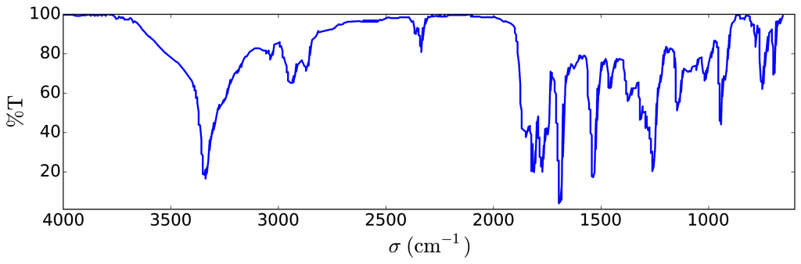

Compound:

* **1** 🞎 **2** 🞎 **3**

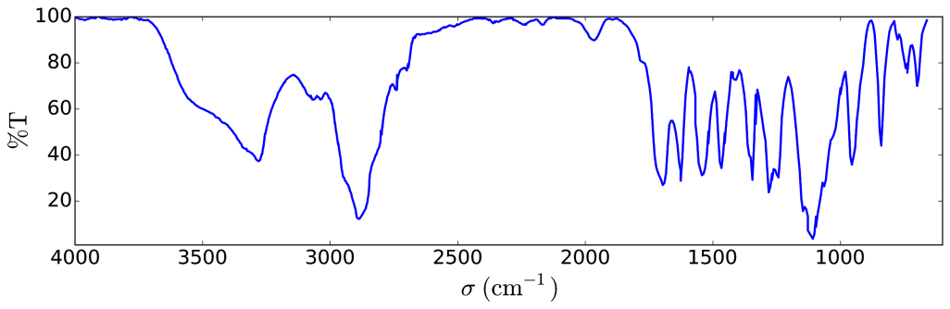

Compound:

* **1** 🞎 **2** 🞎 **3**

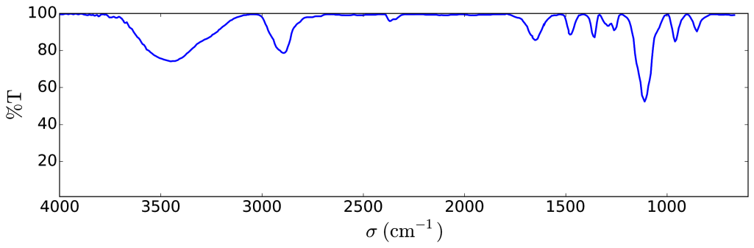

Compound:

* **1** 🞎 **2** 🞎 **3**

1. The 1H NMR spectrum of copolymer **3** (in DMSO-*d6*, at 60 °C, 500 MHz) is reported in Fig. 1. Using some or all of the NMR signals, the areas of which are reported in Table 2, **calculate** its number average molar mass *M*n, considering *n* from question 2. For your calculations, **draw** a circle around the group(s) of atoms you used and **give** their corresponding symbol(s) (α, β…).

|  |  |  |  |  |  |  |  |  |  |  |  |  |  |
| --- | --- | --- | --- | --- | --- | --- | --- | --- | --- | --- | --- | --- | --- |
| Fig. 1 – signals marked with * correspond to the solvent and water. | Table 2   |  |  | | --- | --- | | Peak | Area | | α | 22.4 | | ß | 119 | | γ | 23.8 | | δ | 47.6 | | ε | 622 | |



*M*n = kg mol–1

Provide your answer with two decimal places.

This reaction of **1** with **2** yielded the copolymers **3a** after 20 h, **3b** after 25 h and **3c** after 30 h of reaction at 40 °C. Results of size-exclusion chromatography (SEC) experiments are presented in Fig. 2.

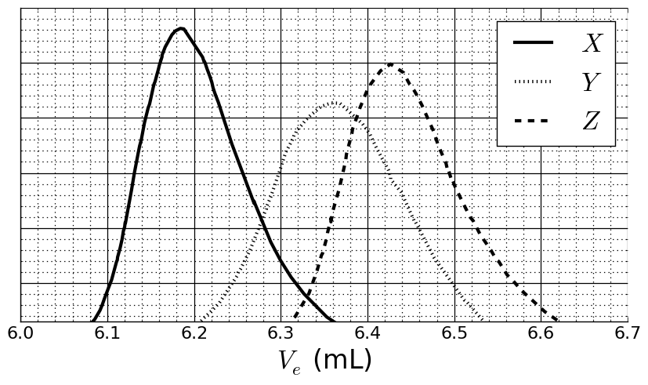

Fig. 2 – SEC chromatograms of **3a**, **3b** and **3c** as a function of the elution volume, Ve.

1. **Match** the signals in Fig. 2 with the copolymers **3a**, **3b** and **3c**.

**3a**: 🞎 *X* 🞎 *Y* 🞎 *Z*

**3b**: 🞎 *X* 🞎 *Y* 🞎 *Z*

**3c**: 🞎 *X* 🞎 *Y* 🞎 *Z*

In order to calibrate the chromatogram, a mixture of standard polymers of known masses (3, 30, 130, 700 and 7000 kg mol−1) has been studied (Fig. 3).

The log value of the molar mass is a linear function of the elution volume, *V*e.

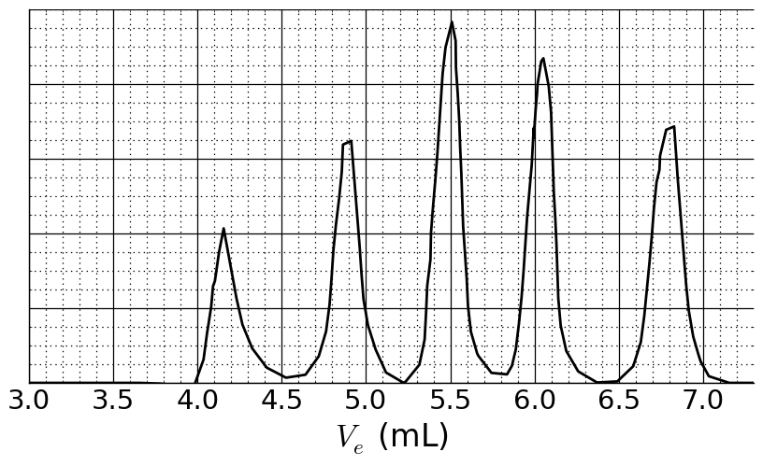

Fig. 3 – SEC chromatogram of the mixture of standards.

1. Based on the SEC curves in Fig. 2 and 3, **determine** *V*e of the polymer that corresponds to curve *X* and use it to **estimate** the degree of polymerization *m* of its second block. **Detail** your calculation; you may use a calculator or plot a graph.

*V*e *=* mL

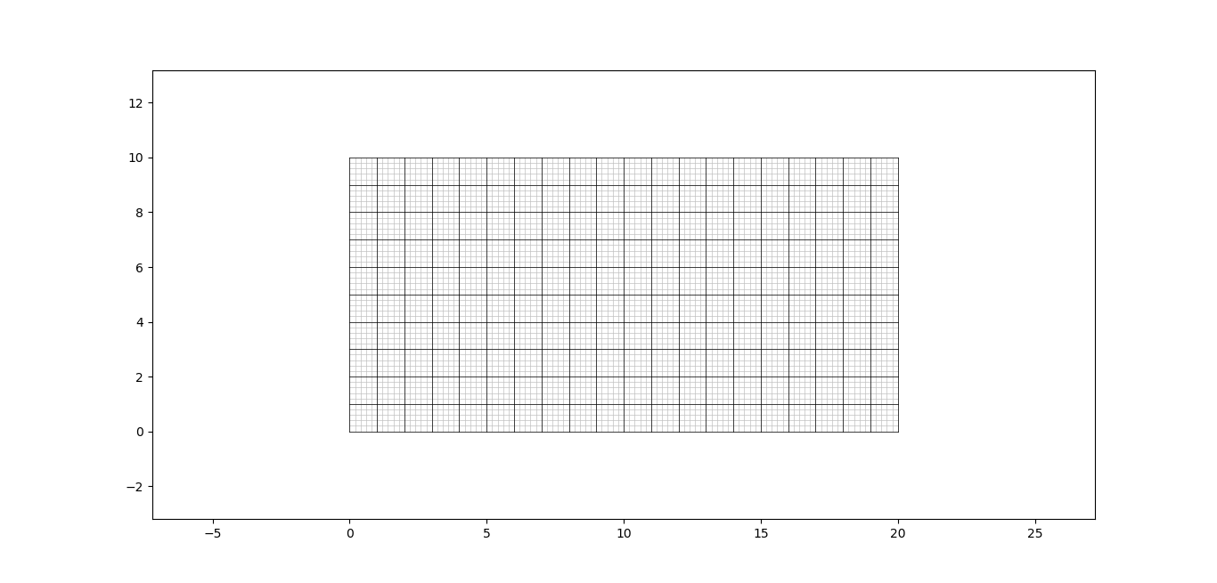

*m* =

Triblock copolymer synthesis

For biological applications, involving the formation of micelles, a triblock copolymer **9** can be synthesized through the introduction of a middle block, **B**,using monomer **5**.



1. **Draw** the structures of **5**, **7** and **8**.

**5** (no other products than **6:A-B** are obtained)

**7** (a gas is formed in the final step)

**8**

1. Amphiphilic block copolymers, such as **9: A-B-C**, can be used for medical applications, as they self-assemble into micelles in water (pH = 7), which can be used as drug carriers. **Assign** each block of the copolymer to a property. **Draw** a scheme of the micelle with only 4 polymer chains.

**A**: 🞎 hydrophobic 🞎 hydrophilic

**B**: 🞎 hydrophobic 🞎 hydrophilic

**C**: 🞎 hydrophobic 🞎 hydrophilic

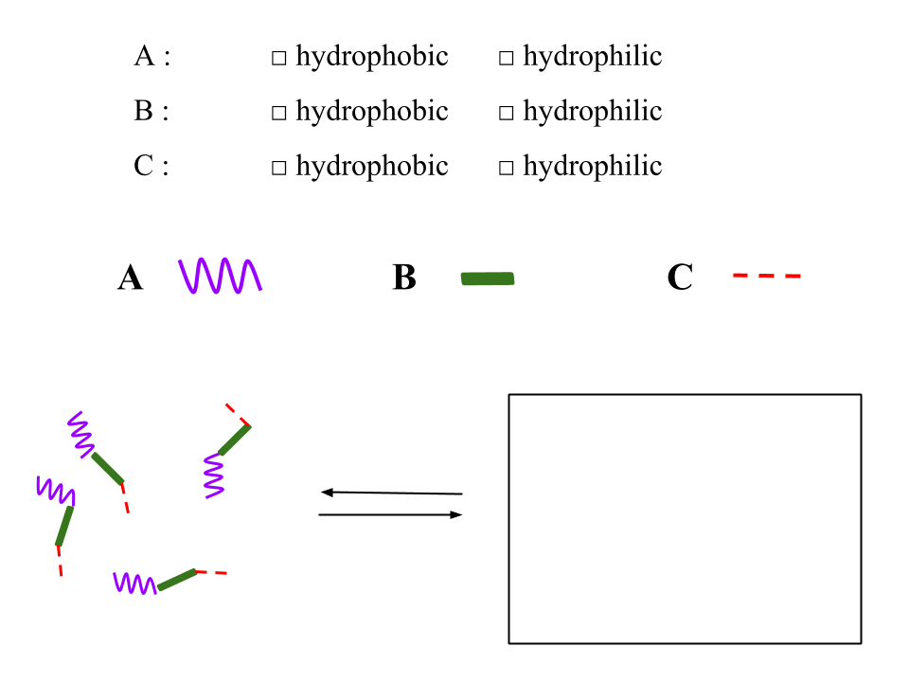

Problem T7: Ring motion in a [2]catenane

|  |  |  |  |  |  |  |  |  |  |  |  |  |  |
| --- | --- | --- | --- | --- | --- | --- | --- | --- | --- | --- | --- | --- | --- |
| **Problem**  **T7**  **6%** | **Question** | **1** | **2** | **3** | **4** | **5** | **6** | **7** | **8** | **9** | **10** | **11** | **Total** |
| Points | 4 | 12 | 2 | 2 | 2 | 5 | 5 | 8 | 4 | 5 | 5 | 54 |
| Score |  |  |  |  |  |  |  |  |  |  |  |  |

In 2016, the Nobel Prize in Chemistry was awarded to J.-P. Sauvage, Sir J. F. Stoddart and B. L. Feringa *"for the design and synthesis of molecular machines"*. An example of these is [2]catenane, a molecule consisting of two interlocked rings. In this system, one macrocycle contains a single phenanthroline (bidentate) ligand and the second contains two ligands: a phenanthroline and a terpyridine (tridentate) ligand. A copper ion is coordinated by one ligand from each macrocycle. Depending on the oxidation state of the copper (+I or +II), two configurations are obtained (Fig. 1).



Fig. 1 – Multi-stability of a ring in a [2]catenane.

The synthesis of the macrocycle is the following:



1. **Draw** the structure of **B**.

**B**

1. **Draw** the structures of **E**, **F** and **G**.

**E**

**F**

**G**

1. Out of the following the reaction conditions, **choose** which one(s) can produce **E** from **D**:

* H+, H2O
* OH−, H2O
* NaBH4, CH3OH
* H2, Pd/C, THF

1. In the synthetic strategy, MsCl is used to obtain:

* a leaving group
* a protecting group
* a deactivating group
* a directing group

1. **G** is obtained by the reaction between **F** and LiBr in acetone. This reaction is:

* electrophilic aromatic substitution
* nucleophilic aromatic substitution
* SN1
* SN2

1. **Draw** the transition state of the rate-determining step of the reaction **F** → **G**, showing the 3D geometry. Depict only one reaction center. The main carbon chain can be represented as an R group.

Transition state:

The synthesis of [2]catenane **L** uses the template effect of a copper complex:



1. **Write** the full electronic configuration of Cu(0) in its ground state. Give the oxidation state of Cu in complex **J** and write the electronic configuration of Cu in the free ion corresponding to **J**.

Electronic configuration of Cu(0):

Oxidation state of Cu in **J**:

Electronic configuration of Cu in **J**:

1. **Select** the geometry of the copper ion in **L**. Assuming an ideal geometry of the ligands around the copper center, **draw** the electronic levels of the d orbitals subject to the crystal field. **Fill** the orbital diagram. **Give** the maximum value of the spin (*S*) for this complex.

The geometry of Cu in **L** is:

* Octahedral
* Tetrahedral
* Square planar
* Trigonal bipyramid

Splitting and filling of d orbitals:

*S* =

1. Out of the following compounds, **choose** the one(s) that can remove the copper ion in **L** to obtain the free [2]catenane:



* CH3CN
* NH4PF6
* KCN
* tren

In [2]catenane **L**, the copper ion can exist in two oxidation states (+I) or (+II), and each of them exhibits a different coordination sphere (tetra- or penta-coordinated, respectively).



Fig. 2 – [2]catenane **L** states

The stability of Cu(I) complexes can be inferred by comparing their electronic structures to that of a noble gas.

1. **Fill** in the blanks with a number or a tick:

The CuIN4 complex has … electrons in the coordination sphere of the metal.

The CuIN5 complex has … electrons in the coordination sphere of the metal.

The CuIN4 complex is 🞎 more / 🞎 less stable than the CuIN5 complex.

1. **Fill** in the solid boxes with the designation of the involved complexes in Fig. 2 and **complete** the sequence to achieve electrochemical control of the system using the following notation for the dashed boxes:  (rotation); + e‒ ; ‒ e‒.



|  |  |  |  |  |  |  |  |  |  |  |  |  |  |  |  |  |  |
| --- | --- | --- | --- | --- | --- | --- | --- | --- | --- | --- | --- | --- | --- | --- | --- | --- | --- |
| **Problem**  **T8**  **6%** | **Question** | **1** | **2** | **3** | **4** | **5** | **6** | **7** | **8** | **9** | **10** | **11** | **12** | **13** | **14** | **15** | **Total** |
| Points | 2 | 6 | 2 | 2 | 11 | 2 | 4 | 3 | 4 | 2 | 6 | 8 | 2 | 6 | 4 | 64 |
| Score |  |  |  |  |  |  |  |  |  |  |  |  |  |  |  |  |

Problem T8: Identification and synthesis of inositols

In this problem, we define “3D structure” and “perspective formula” as indicated for β-glucose in the following figure.



Inositols are cyclohexane-1,2,3,4,5,6-hexols. Some of these 6-membered carbocycles, in particular *myo*-inositol, are involved in a number of biological processes.

Structure of *myo*-inositol

1. **Draw** the structural formula of inositols, without stereochemical details.

This family of molecules contains 9 different stereoisomers, including enantiomers.

1. **Draw** all 3D structures of the stereoisomers that are optically active.

The structure of a specific inositol, called *myo*-inositol, is studied here. Only one of its chair conformers is predominant and its structure can be deduced from its 1H NMR spectrum. The spectrum below was obtained at 600 MHz in D2O. No other signal from that compound was observed in the spectrum. The integration is indicated on the spectrum below each signal.

../RMN.pdf

1. **Give** the molecular formula of the predominant compound derived from *myo*-inositol in this sample that is consistent with the number of protons observed in the 1H NMR spectrum.
2. Based on the number and integrations of the proton signals, **give** the number of symmetry plane(s) that exist(s) in this molecule.
3. **Complete** the following perspective drawing of the most stable conformation of *myo*-inositol. Then **label** each hydrogen with the corresponding letter (**a**, **b**, **c** or **d**) according to the NMR spectrum above. Proton **a** must be on carbon **a** on the following representation. **Draw** its 3D structure.

|  |  |
| --- | --- |
|  | 3D structure: |

Synthesis of inositols

For medicinal applications, it is useful to synthesize some inositol phosphates on a large scale. We will study the synthesis of inositol **2** from bromodiol **1**.



1. **Choose** the correct structural relationship(s) between **2** and **3**.

* enantiomers
* epimers
* diastereomers
* atropoisomers

Inositol **2** can be obtained from compound **1** in 7 steps.





1. **Draw** the 3D structure of **4**.

**4**

1. The reaction leading to **5** occurs on the double bond with the highest electron density. Consider below the structure of 1-bromo-1,3-cyclohexadiene, which is a substructure of **4**. **Circle** the double bond with the highest electron density. **Represent** all the electronic effects due to the bromine.



1. **Draw** the 3D structure of the major diastereomer **5**.

**5**

1. **Give** the total number of stereoisomers of **5** possibly obtained by this synthesis, starting from enantiopure compound **1**.
2. For the step **5** **→ 6**, another product with the same molecular formula, denoted **6’**, can be produced. **Draw** the 3D structures of **6** and **6’**.

|  |  |
| --- | --- |
| **6** | **6’** |

1. **Draw** the 3D structures of major diastereomers **8** and **9**.

|  |  |
| --- | --- |
| **8** | **9** |

1. **Select** the right set(s) of conditions **A** to obtain **2**.

* H2, Pd/C
* K2CO3, HF
* HCOOH, H2O
* BF3·OEt2

1. If the bromine is not present in compound **1**, in addition to **2**, another stereoisomer would be obtained. Considering that the stereoselectivity of the reactions that take place in the synthesis remains unchanged and that the following steps involve the same number of equivalents as for **2**, **draw** the 3D structure of this stereoisomer and **give** its relationship with **2**.

* enantiomers
* epimers
* diastereoisomers
* atropoisomers

1. During the synthesis of **2** from **1, choose** the removal step(s) of protecting or directing groups.

* **1** → **4**
* **4** → **5**
* **5** → **6**
* **6** → **7**
* **7** → **8**
* **8** → **9**
* **9** → **2**

|  |  |  |  |  |  |  |  |  |  |  |  |  |  |  |  |
| --- | --- | --- | --- | --- | --- | --- | --- | --- | --- | --- | --- | --- | --- | --- | --- |
| **Problem**  **T9**  **7%** | **Question** | **1** | **2** | **3** | **4** | **5** | **6** | **7** | **8** | **9** | **10** | **11** | **12** | **13** | **Total** |
| Points | 2 | 2 | 4 | 3 | 2 | 17 | 1 | 1 | 2 | 4 | 2 | 2 | 2 | 44 |
| Score |  |  |  |  |  |  |  |  |  |  |  |  |  |  |

Problem T9: Synthesis of levobupivacaine

Part I.

The local anesthetic bupivacaine (marketed as Marcaine) is on the World Health Organization List of Essential Medicines. Although the drug is currently used as a racemic mixture, it was demonstrated that one enantiomer of bupivacaine, levobupivacaine, is less cardiotoxic and, therefore, safer than the racemate. Levobupivacaine can be synthesized from the natural amino acid l-lysine.



1. **Assign** the absolute configuration of the stereogenic center in l-lysine hydrochloride and **justify** your answer by classifying the substituents in order of their priority.

|  |  |
| --- | --- |
| Configuration:  🞏 *R*  🞏 *S* | Priority 1 > 2 > 3 > 4: |

1. The prefix l in l-lysine refers to relative configuration. **Choose** all correct statements:

* All natural l-amino acids are levorotatory.
* Natural l-amino acids can be levorotatory or dextrorotatory.
* All natural l-amino acids are (*S*).
* All natural l-amino acids are (*R*).

Often, we want only one of the amino groups in l-lysine to react. A Cu2+ salt with excess aqueous hydroxide can selectively mask the reactivity of one of the amino groups. After the complex is formed, only the non-complexed NH2 group is available to react.

1. Considering that l-lysine acts as a bidentate ligand and that two l-lysines coordinate to one Cu2+ ion in the presence of aqueous hydroxide, **draw** the structure of the intermediate complex.

Complex

Fortunately, in the synthesis of levobupivacaine shown below, the same amino group reacts even without Cu2+ salt.



From this point on, you can use the abbreviations proposed in the scheme above.

1. **Draw** the structure of compound **A**, including the appropriate stereochemistry.

**A**

1. Transformation of l-lysine into **A** is (**choose** proper answer(s)):

* an enantioselective reaction.
* an enantiospecific reaction.
* a regioselective reaction.

1. **Draw** the structures of compounds **B**–**F**, including the appropriate stereochemistry.

|  |  |
| --- | --- |
| **B** C14H20N2O4 | **C** C16H21NO6 |
| **D** | **E** C29H34N2O6S |
| **F** C21H28N2O4S |  |

1. What is the role of DCC in the transformation **C** → **D**?

* Protecting group for the amino group.
* Protecting group for the hydroxy group.
* Activating agent for the amide bond formation.

1. TsCl is used in the synthesis to enable:

* Nucleophilic substitution of an amino group.
* Electrophilic substitution of an amino group.
* Nucleophilic substitution of a hydroxy group.
* Electrophilic substitution of a hydroxy group.

1. **Mark** all possible reagents which could be used as reagent **H**:

🞎 diluted HCl 🞎 Zn/HCl

🞎 K2CO3 🞎 H2SO4

🞎 diluted KMnO4 🞎 diluted NaOH

🞎 SOCl2 🞎 PCl5

1. **Draw** the structure of levobupivacaine, including the appropriate stereochemistry.

Levobupivacaine C18H28N2O

Part II.

The synthesis of levobupivacaine requires the use of enantiomerically pure l-lysine. A common method to confirm the enantiomeric purity of aminoacids is their transformation into amides using Mosher's acid (see the structure of the (*S*) isomer below).



1. **Draw** the structure of the amide formed when the α-amino group of l-lysine is derivatized with(*S*)-Mosher's acid. Clearly show the stereochemistry of each chiral center.
2. **How many products** will be formed from racemic lysine and (*S*)-Mosher's acid (consider that only the α-amino group of lysine is derivatized)?

* Two diastereoisomers.
* Four diastereoisomers.
* A racemic mixture of two enantiomers.
* Four compounds: two enantiomers and two diastereoisomers.

1. **Choose** the method(s) which can be used to quantitatively determine the enantiomeric purity of lysine after its derivatization with (*S*)-Mosher's acid:

* NMR spectroscopy.
* Liquid chromatography.
* Mass spectrometry.
* UV-vis spectroscopy.